MODIFICATION TO Z MOTOR POWER WIRING

- PARTS:

QUANTITY: PART #: NOMENCLATURE: LENGTH:

1 PER MACHINE 18682- MOTOR, SERVO, Z-AXIS N/A

1 PER MACHINE 17585-3 HOUSING, 4-PIN, MOLEX N/A

4 PER MACHINE 18729- TERMINAL, CRIMP, GOLDPLATED N/A

7 PER MACHINE 46034- TUBING SHRINK, 1/8” BLACK 3/8 INCH

1 PER MACHINE 46034- TUBING, SHRINK, 1/8” BLACK 1-1/8 INCH

2 PER MACHINE 46160-1 TUBING, SHRINK, ¼” CLEAR 2 INCHES

1 PER MACHINE 19284- CABLE, ULTRAFLEX, 26 AWG, 4-CON 27 INCHES

- MOTOR CABLE SPLICE ASSEMBLY:

- CUT THE MOTOR CABLE TO A 10 INCH LENGTH FROM THE MOTOR.

- STRIP ½ INCH OF OUTER INSULATION FROM THE END OF THE MOTOR CABLE.

- TWIST THE SHIELDING STRANDS INTO A SINGLE WIRE.

- SLIDE A 3/8 INCH LONG PIECE OF SHRINK TUBING (46034-) OVER THE TWISTED SHIELD WIRE, DOWN TO THE OUTER INSULATION.

- SHRINK THE TUBING OVER THE SHIELD WIRE USING A HEAT GUN.

- TRIM THE EXPOSED SHIELD WIRE TO 1/8” LENGTH, AND TIN IT.

- SLIDE A 3-INCH LONG PIECE OF SHRINK TUBING (46160-) ONTO THE MOTOR CABLE, DOWN TO THE MOTOR.

- STRIP 1/8 INCH OF INSULATION FROM ALL OF THE MOTOR CABLE WIRES, AND TIN THEM.

- STRIP ½ INCH OF OUTER INSULATION FROM THE END OF THE 27 INCH EXTENSION CABLE.

- TWIST THE SHIELDING STRANDS INTO A SINGLE WIRE.

- SLIDE A 3/8-INCH LONG PIECE OF SHRINK TUBING (46034-) OVER THE TWISTED SHIELD WIRE, DOWN TO THE OUTER INSULATION.

- SHRINK THE TUBING OVER THE SHIELD WIRE USING A HEAT GUN.

- TRIM THE EXPOSED SHIELD WIRE TO 1/8” LENGTH, AND TIN IT.

- STRIP 1/8 INCH OF INSULATION FROM ALL OF THE EXTENSION CABLE WIRES, AND TIN THEM.

O. SLIDE FIVE 3/8-INCH LONG PIECES OF SHRINK TUBING (46034-) OVER THE TINNED WIRES OF THE EXTENSION CABLE, DOWN TO THE OUTER INSULATION.

- SOLDER THE WIRES OF THE TWO CABLES TOGETHER, ACCORDING TO DIAGRAM 1.

- SLIDE THE SHRINK TUBING OVER THE SOLDER JOINTS.

- SHRINK THE TUBING USING A HEAT GUN.

NOTE 1
MAKE SURE THERE ARE NO EXPOSED WIRES AT THE SPLICES.

- SLIDE THE 3-INCH LONG PIECE OF SHRINK TUBING (46160-1) OVER THE SPLICE.

T. SHRINK THE TUBING USING A HEAT GUN.

- MOTOR CABLE EXTENSION TERMINATION:

- STRIP 1-¼ INCHES OF OUTER INSULATION FROM THE END OF THE EXTENSION CABLE.

B. TWIST THE SHIELDING STRANDS INTO A SINGLE WIRE.

- SLIDE A 1-1/8 INCH LONG PIECE OF SHRINK TUBING (46034-) OVER THE TWISTED SHIELD WIRE, DOWN TO THE OUTER INSULATION.

- SHRINK THE TUBING OVER THE SHIELD WIRE USING A HEAT GUN.

- TRIM THE EXPOSED SHIELD WIRE TO 1/8” LENGTH, AND TIN IT.

- SLIDE A ½ INCH LONG PIECE OF SHRINK TUBING (46160-) ONTO THE EXTENSION CABLE, OVER THE EDGE OF THE OUTER INSULATION.

- SHRINK THE TUBING OVER THE END OF THE OUTER INSULATION USING A HEAT GUN.

- STRIP 1/8 INCH OF INSULATION FROM ALL OF THE EXTENSION CABLE WIRES.

- CRIMP FOUR GOLDPLATED TERMINALS TO THE WIRES AND TIN THEM, ACCORDING TO DIAGRAM 2.

- INSERT THE CRIMPED WIRES INTO THE HOUSING, ACCORDING TO DIAGRAM 1.

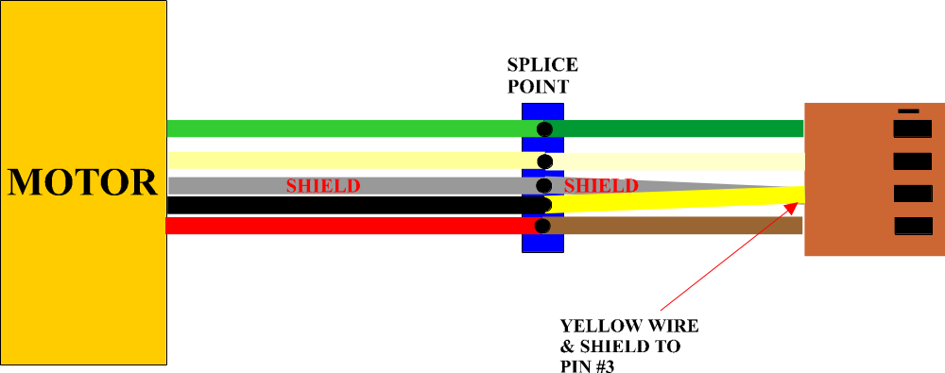

DIAGRAM 1
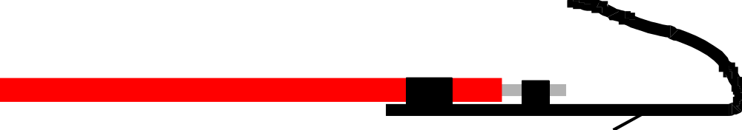

DIAGRAM 2

